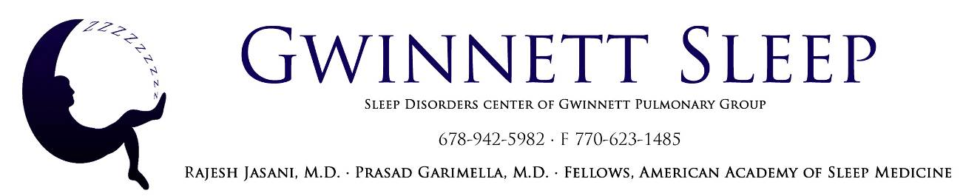

INSURANCE MAY ALLOW A REPLACEMENT PAP MACHINE ONCE EVERY FIVE YEARS

REPLACEMENT STANDARDS
HCPC Code Description Max. Allowance
A7027 | Combination oral/nasal mask | 1 per 3 months
A7028 | Oral cushion for combination oral/nasal mask-Replacement | 2 per 1 month
A7029 | Nasal pillows for combination oral/nasal mask-Replacement | 2 per 1 month
A7030 | Full face mask used with PAP device | 1 per 6 months
A7031 | Full face cushion , each | 1 per 1 months
A7032 | Nasal cushion for nasal mask | 2 per 1 month
A7033 | Replacement pillows for nasal mask | 2 per 1 month
A7034 | Nasal interface(mask or pillow type) used with PAP device | 1 per 6 months
A7035 | Headgear, used with PAP device | 1 per 6 months
A7036 | Chin strap, used with PAP device | 1 per 6 months
A7037 | Tubing, used with PAP device | 1 per 3 months
A7038 | White filter, disposable, used with PAP device | 1 per 1 month
A7039 | Filter, non-disposable, used with PAP | 1 per 6 months
A7046 | Water chamber for humidifier used with PAP device | 1 per 6 months
A7044 | Oral interface with PAP device | 1 per 6 months
A4604 | Tubing with Integrated Heating Element for use with PAP device | 1 per 3 months
Replacement schedules are subject to change based upon physician order, medical condition and the discretion of the insurance plan. Deductible and co-insurance may apply.

